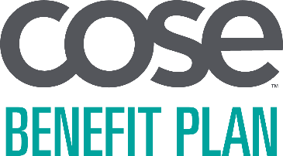

<DATE>

<CONTACT NAME>
<ADDRESS 1>
<ADDRESS 2>
<CITY>, <STATE> <ZIP>

Dear <CONTACT NAME>,

Enclosed is the COSE Benefit Plan annual notice of health benefit reminders. This notice includes important information about the following benefits:

- Newborns’ and Mothers’ Health Protection Act (NMHPA)
- Health Insurance Portability and Accountability Act (HIPAA) Privacy Policy
- Women’s Health and Cancer Rights Act (WHCRA)
- Consolidated Omnibus Budget Reconciliation Act of 1985 (COBRA)
- Children’s Health Insurance Program Reauthorization Act (CHIPRA)
- Michelle’s Law
- Genetic Information Nondiscrimination Act (GINA)

As you have been made aware in your participation agreement for the COSE Benefit Plan, you are considered by the Employee Retirement Income Security Act of 1974 (ERISA) to be the plan sponsor of your health benefit plan. As such, you are responsible for certain duties which include communicating certain benefit updates and notices to your plan participants. The included reminders are in support of your fulfillment of these obligations.

Please note that this year’s annual notice includes a reminder to let plan participants know they can download a copy of their 1095-B tax form from My Health Plan, our secure member portal, at MedMutual.com/Member. Hard copies will only be mailed to members who call our Customer Care team to request one.

Please distribute copies of the enclosed notice to each of your plan participants. If you have questions about this notice or its distribution, please contact your broker or Medical Mutual sales representative.

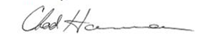
Sincerely,

Chad Hamman, Vice President, Membership Development & Service
Council of Smaller Enterprises (COSE), A program of the Greater Cleveland Partnership

